HAMPTON ROADS HOUSING CONSORTIUM

19th ANNUAL HOUSING AWARDS NOMINATION PACKET

HONORING OUR MEMBERS WHO ARE MAKING A DIFFERENCE IN THE AFFORDABLE HOUSING INDUSTRY

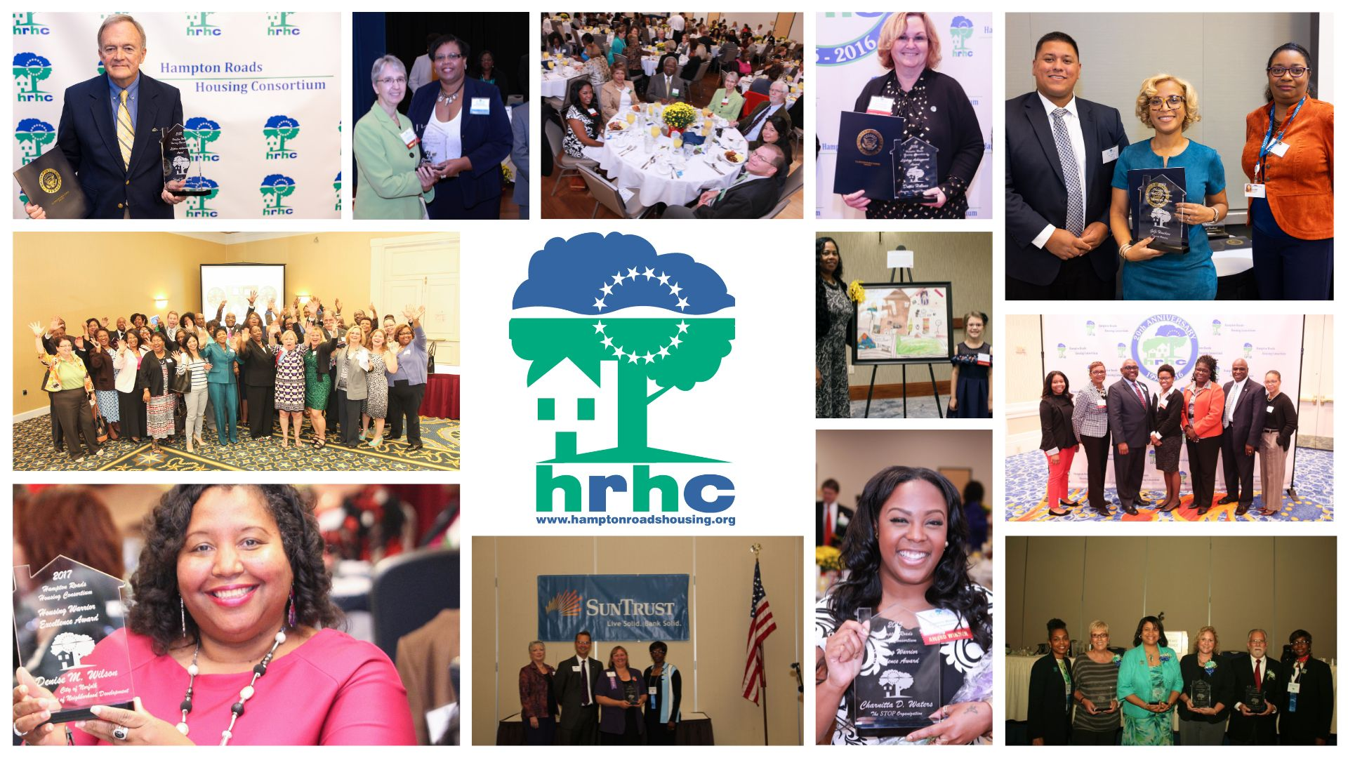

Hampton Roads Housing Consortium
c/o HRPDC
723 Woodlake Drive - Chesapeake, VA 23320
757-420-8300
www.hamptonroadshousing.org
info@hamptonroadshouisng.org

Hampton Roads Housing Consortium

19th Annual Housing Awards

Nomination Form

The Hampton Roads Housing Consortium is accepting nominations for the 19th Annual Housing Awards to be presented on Thursday, November 13, 2025. This program will be held at Founders Inn & Spa, Virginia Beach, VA. Awards will be presented in the following categories:

HRHC Lifetime Achievement Award
This award recognizes an individual who demonstrated lifetime successes committed to improving families' lives and our communities' well-being. This awardee will have strived to positively impact households across all income levels that deserve fair opportunities to buy or rent safe, decent, affordable and suitable housing for their needs. This individual must demonstrate exemplary, state-of-the-art responses to providing affordable housing or support services.

HRHC Housing Warrior: Excellence Award
This award recognizes an individual that has been instrumental in creating or supporting affordable housing, implementing housing-related programs, educational efforts, or assisting others in solving challenging housing issues through creative and impactive programs. HRHC’s Housing Warrior should be an individual that has accomplished such actions through personal commitment and sacrifice.

HRHC Housing Partner: Special Project Award
This award recognizes an individual or organization demonstrating outstanding commitment, effectiveness, and innovation in meeting any housing-related needs through a project or specific program. Special consideration will be given to nominations that meet any or all of the following criteria:
- Address a particularly pressing affordable housing need
- Use creative financing products and outreach to provide housing for a disadvantaged population in which the organization serves
- Preserve an existing endangered affordable housing resources
- Serve the needs of unique populations (e.g., elderly, disabled, homeless).

HRHC Across the Region Service Award
This award recognizes an organization or individual for distinguished service in improving housing conditions on a regional level. The recipient of this award should be a housing advocate instrumental in spreading regional efforts that blur jurisdictional boundaries and in protecting and improving the region’s quality of life through housing initiatives. Special consideration will be given to nominations that meet any or all of the following criteria:

- Implement practices that can improve livability in the region.
- Promoted activities that focus on leadership and/or education relating to housing for special needs populations, creation of new affordable housing units, housing advocacy, etc.
- Work and/or programs benefit multiple cities and counties or contain aspects of multi-discipline collaboration.

Hampton Roads Housing Consortium

19th Annual Housing Awards

NOMINATING PROCEDURES:

- Nominees must be current members of the Hampton Roads Housing Consortium. (Please visit our website for a listing of all active members)
- Individuals or organizations are encouraged to nominate their own project/activities but may also select those of others.
- Nominations will be reviewed, and winners selected by the HRHC Selection Committee.
- Nominations must be received by 5:00 p.m. on Friday, October 24, 2025.
- The Nomination form must be typed or printed legibly. The nomination must clearly define how the Nominee meets the award criteria. Please be brief but detailed. Additional information such as newspaper articles, resumes, or letters of support may be included with the nomination. Additional information should be limited to no more than five items.
- Nominations will be accepted via fax or email.
- Winners will be notified in advance and presented the award at the Awards Ceremony on Thursday, November 13, 2025.

SUBMISSION:

Nomination Forms must be received by 5:00 p.m. on Friday, October 24, 2025

Submit Nominations via fax or email to:

2025 HRHC Housing Awards Selection Committee Chairperson
Fax: 757-523-4881
Phone: 757-420-8300
Email: info@hamptonroadshousing.org

If you have any questions or problems with submittal, please contact Ashley Jarvis, 2025 Nomination Chair, at ajarvis@vbcdc.org.

Award Nomination Form

- Category for this nomination (Check only one category per nomination).
Lifetime Achievement Award
Housing Warrior: Excellence Award
Housing Partner: Special Project
Across the Region Service Award
- Nominee Information:
Nominee Name:
Title of Nominee (if applicable):
Nominee's Agency/Company:
Address of Nominee:
Nominee's Telephone:
Nominee's Email:
Nominee's Years of Service:

- Describe how the Nominee met the criteria for the award. Additional pages or material may be attached if appropriate. Include any photos, brochures, etc.

Nomination Submitted By:
 | Signature |  | Date

Print Name & Title:
Address:
Telephone:
Email:

